Figure 1 – Broad typology of smallholder value chain case studies

Figure 2 - Case studies by country (n=344)

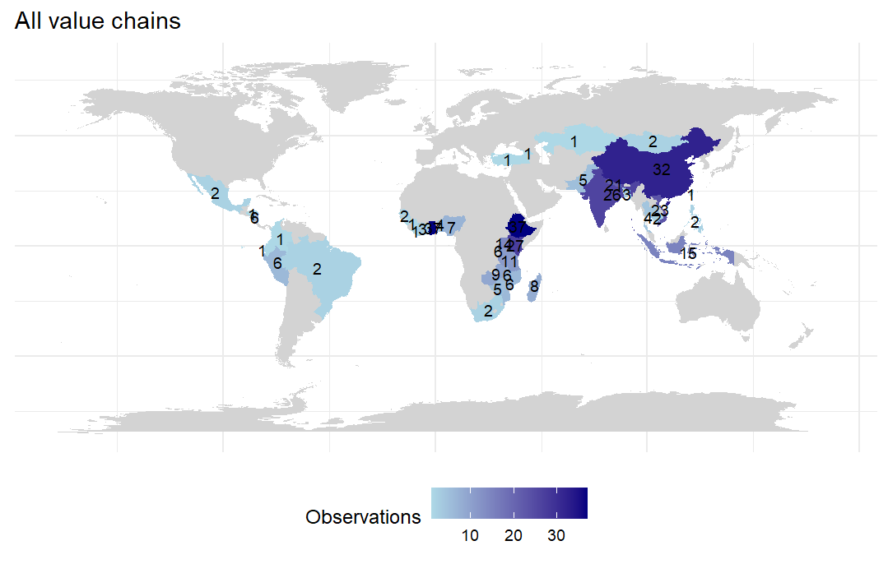

Figure 3 - All case studies - year published

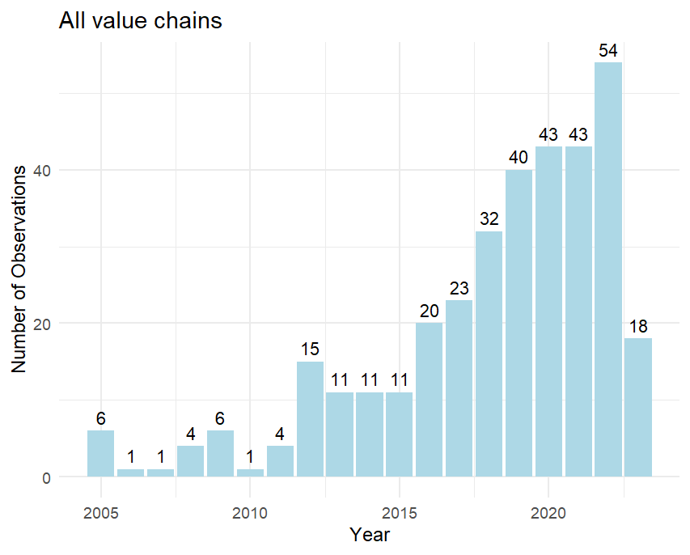

Note – Database searches conducted May 2023

Figure 4 - Contract farming (and other buyer driven value chains) case studies - year published

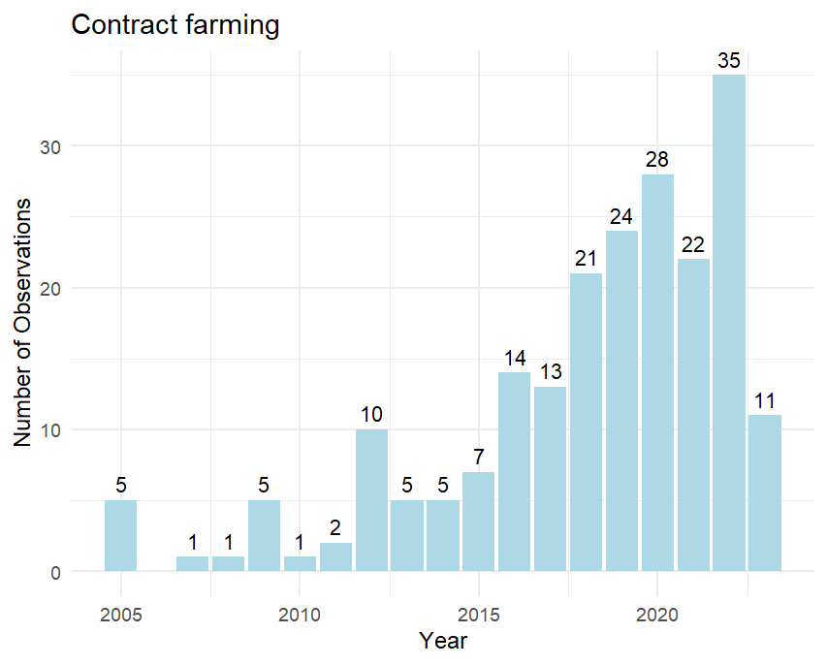

Note – Database searches conducted May 2023

Figure 5 - Cooperatives (and other producer driven value chains) case studies - year published

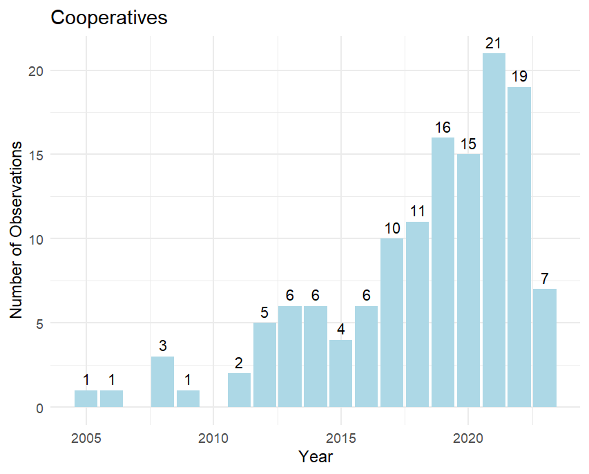

Note – Database searches conducted May 2023

Figure 6 – All value chain case studies – crop type

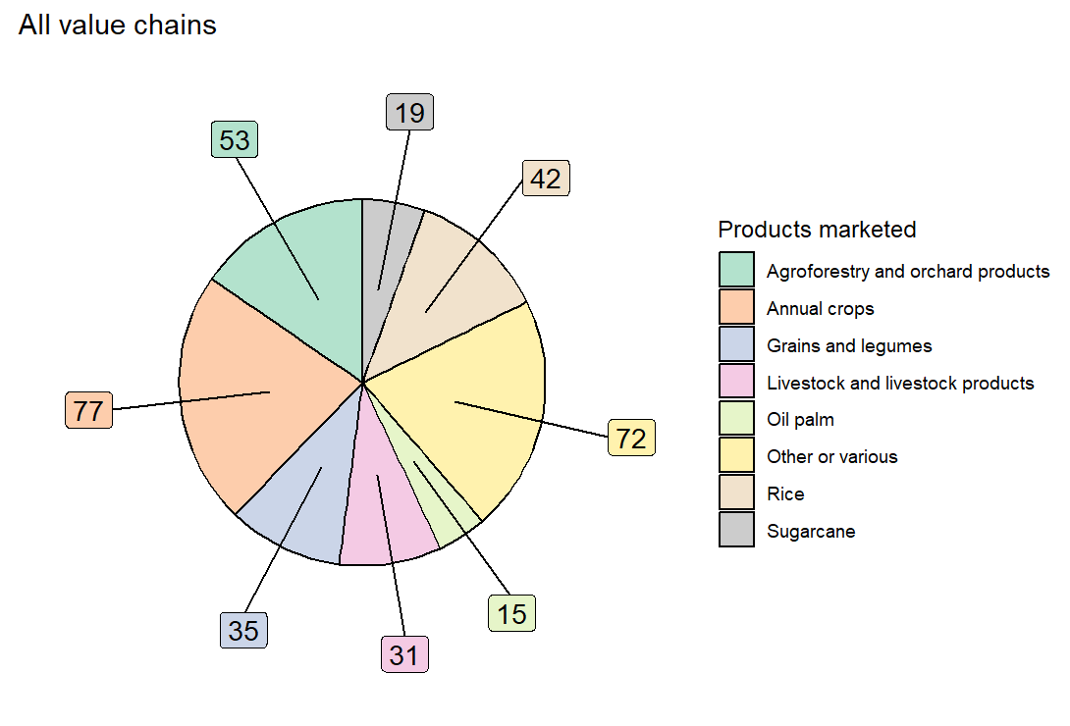

Figure 7 – Contract farming (and other buyer driven value chains) case studies – crop type

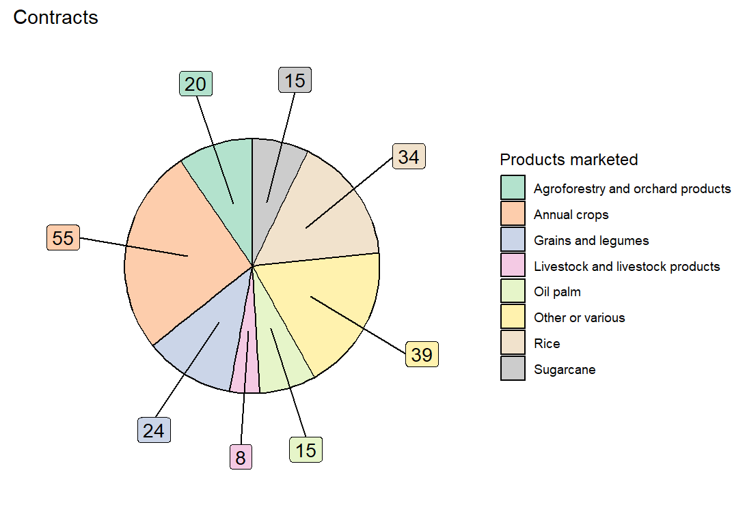

Figure 8 – Cooperatives (and other producer driven value chains) case studies – crop type

Figure 9 – Type of analysis – all case studies

Note – Case studies may use more than one analysis method.

Figure 10 – Type of analysis data – all case studies

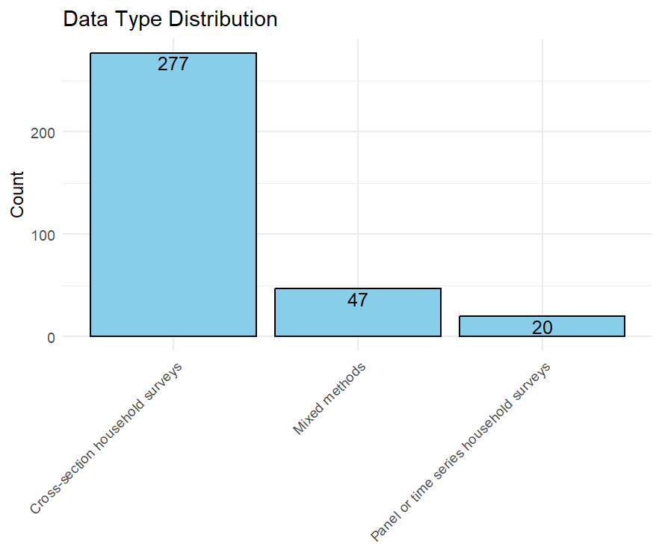

Figure 11 – Number of value outcomes assessed – all value chains

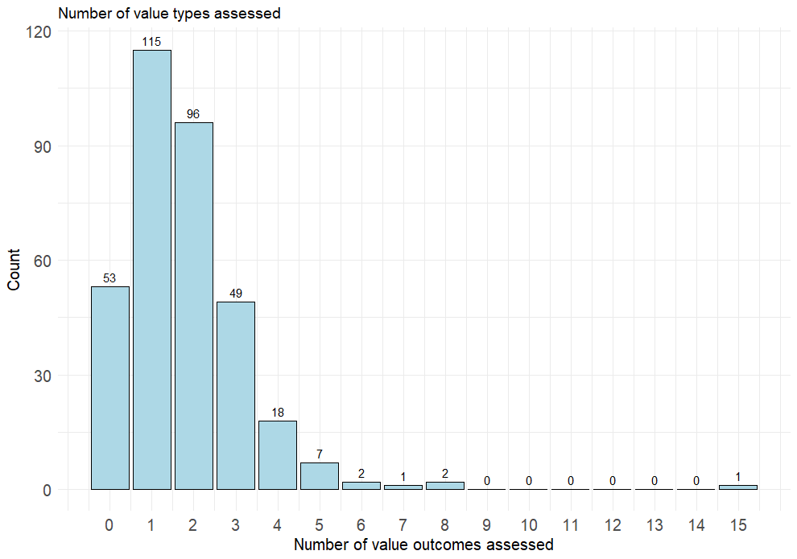

Figure 12 – Number of value outcomes assessed (grouping all farm and household monetary outcomes) – all case studies

